## horizontal line



Project Report

05.12.2024

**─**

I221156, 1220948 , 1220831

# 

# Screenshots of updated forms below:

**Main interface:**

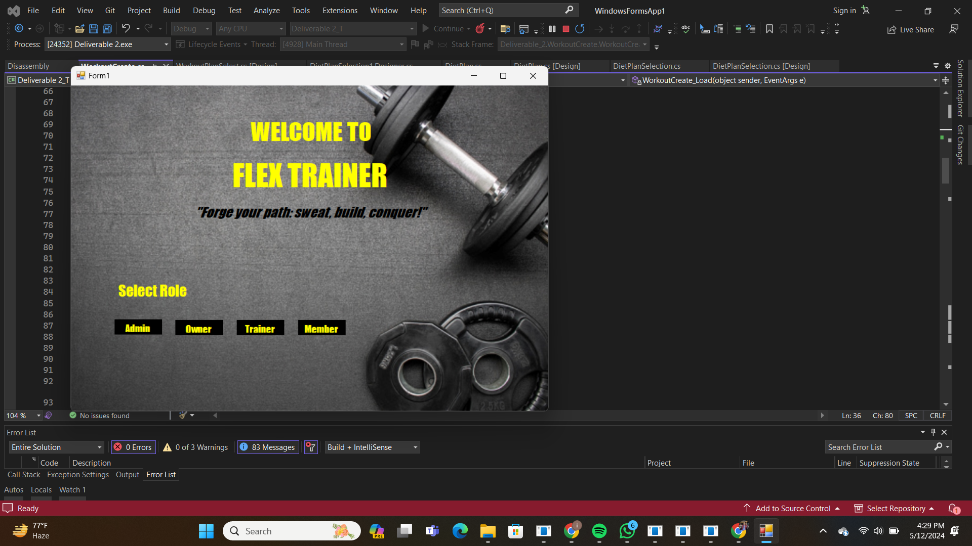

**User roles allow navigation according to user type.**

**Member interface:**

user form facilitates seamless registration, enabling individuals to join the gym and access its services efficiently. Once enrolled, members can utilize the form to manage their personal information, including height, weight, and membership details, ensuring accurate tracking of progress over time. Additionally, the form provides a platform for members to customize their workout plans, selecting from a diverse range of routines designed to meet varying fitness goals. Moreover, the form enables users to book personal training sessions, schedule classes, and track their attendance, empowering them to optimize their gym experience and stay committed to their fitness regimen.

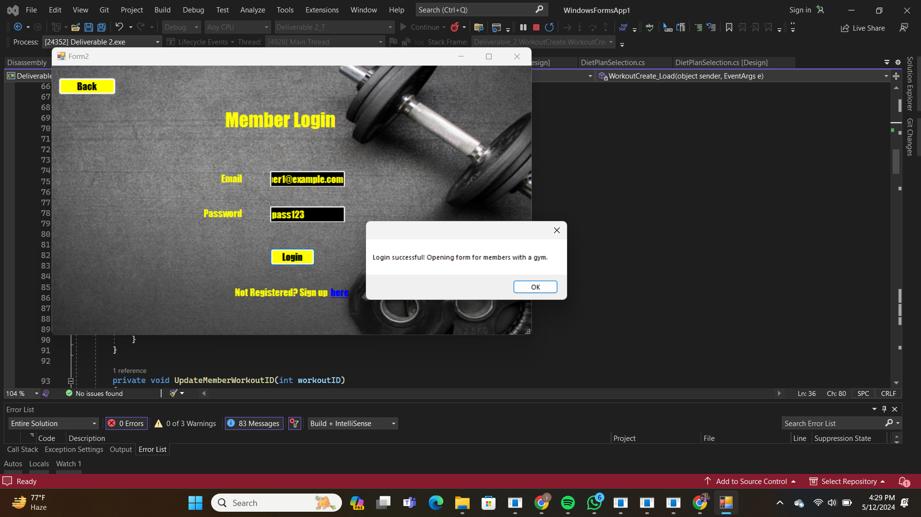

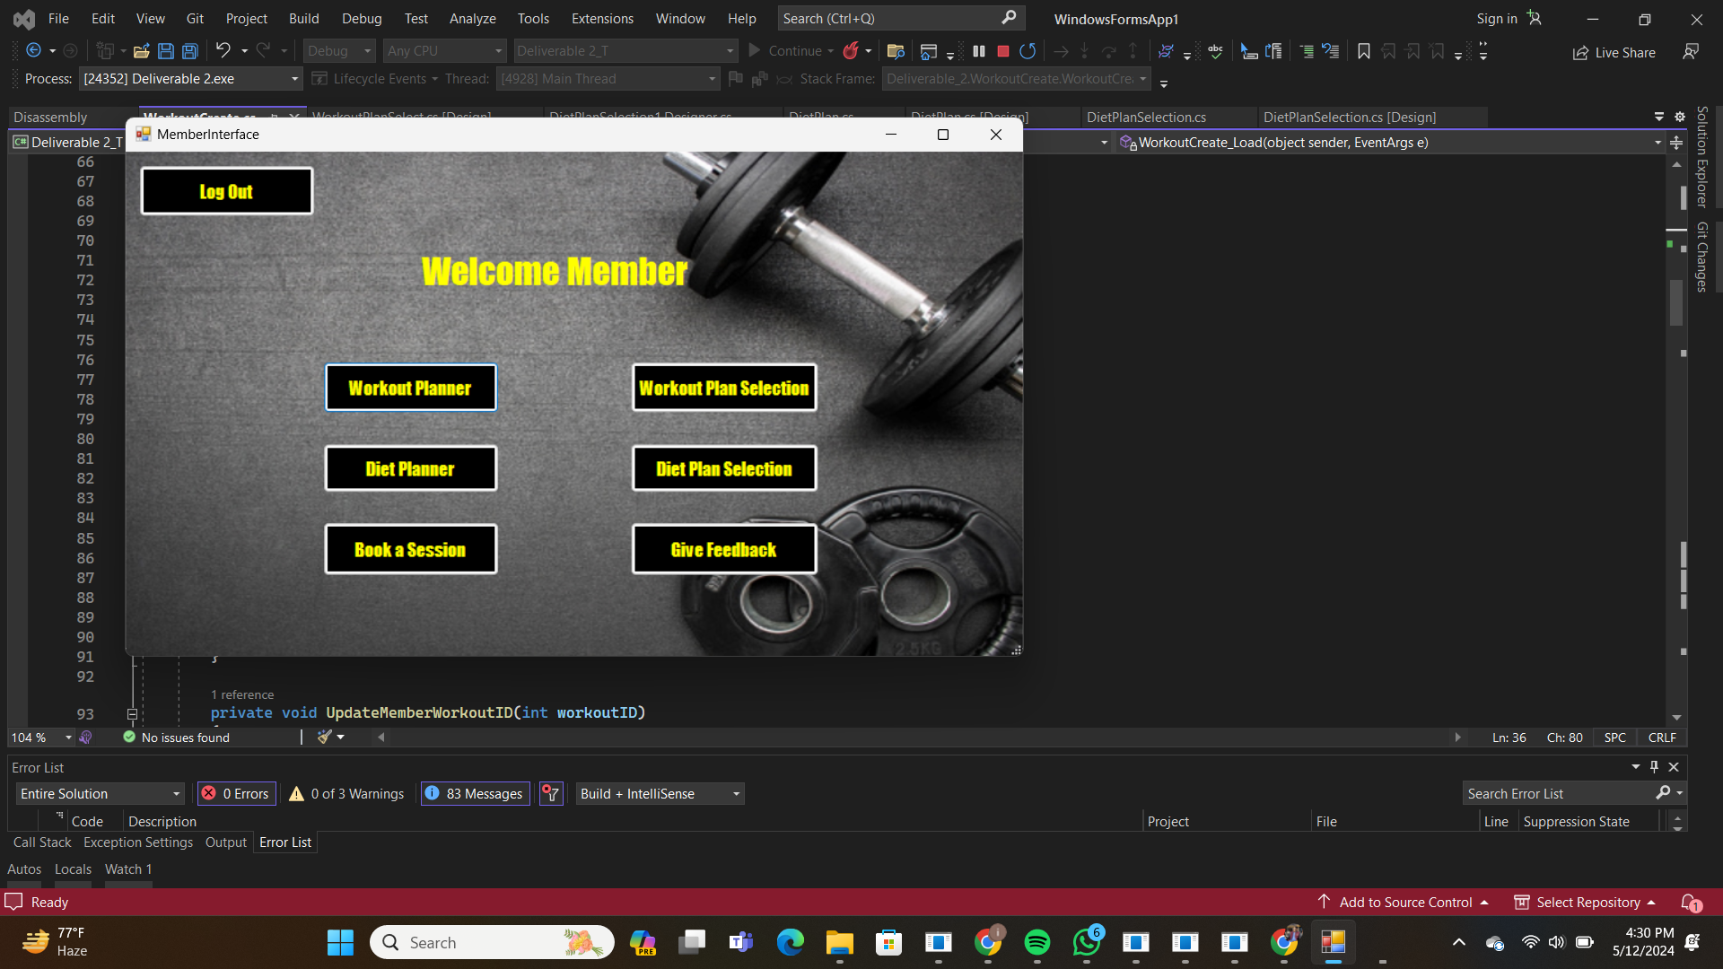

# 

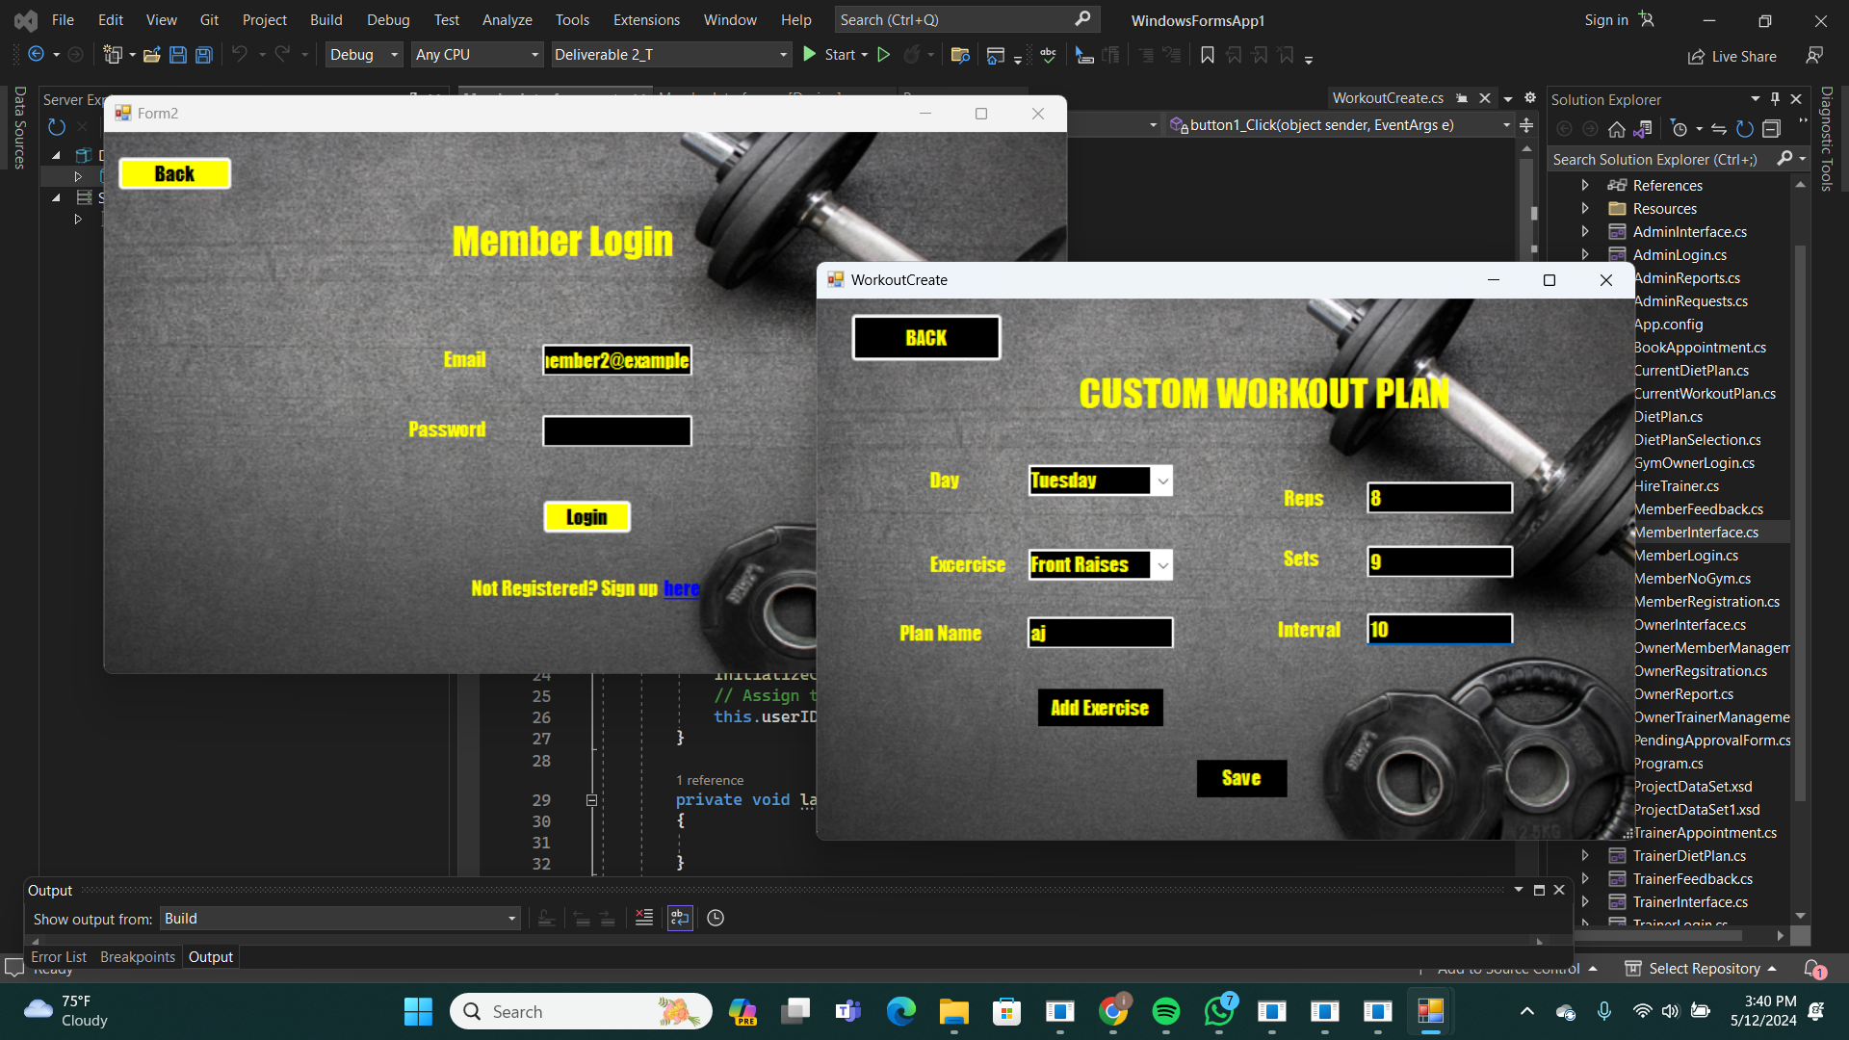

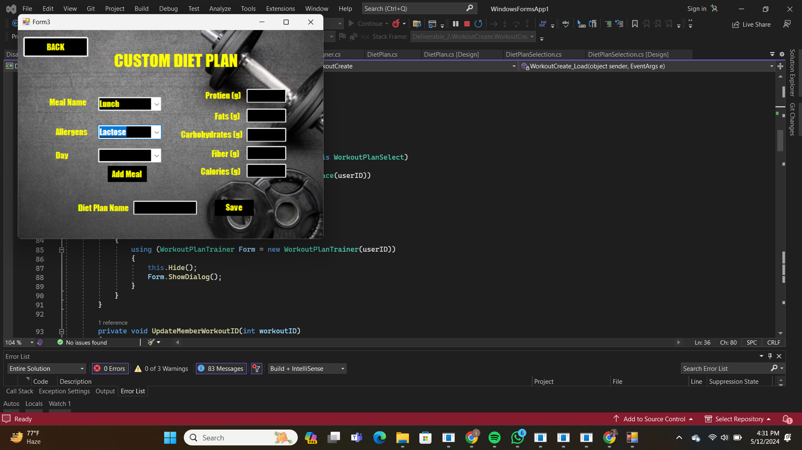

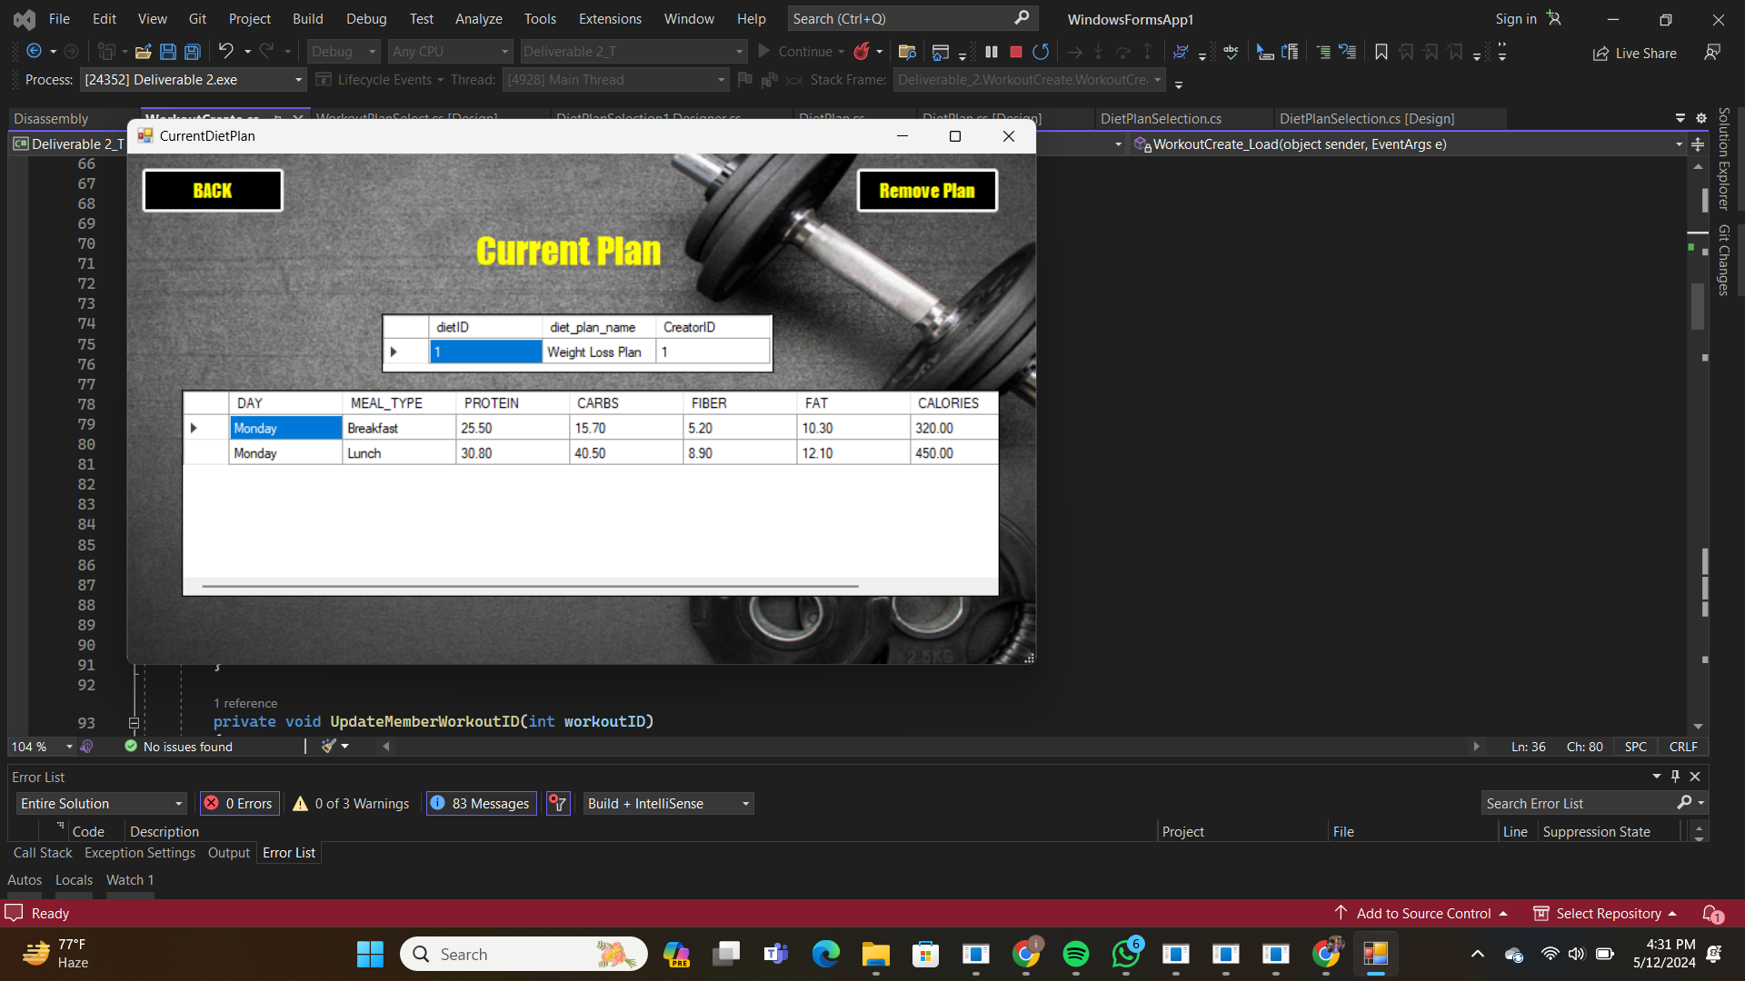

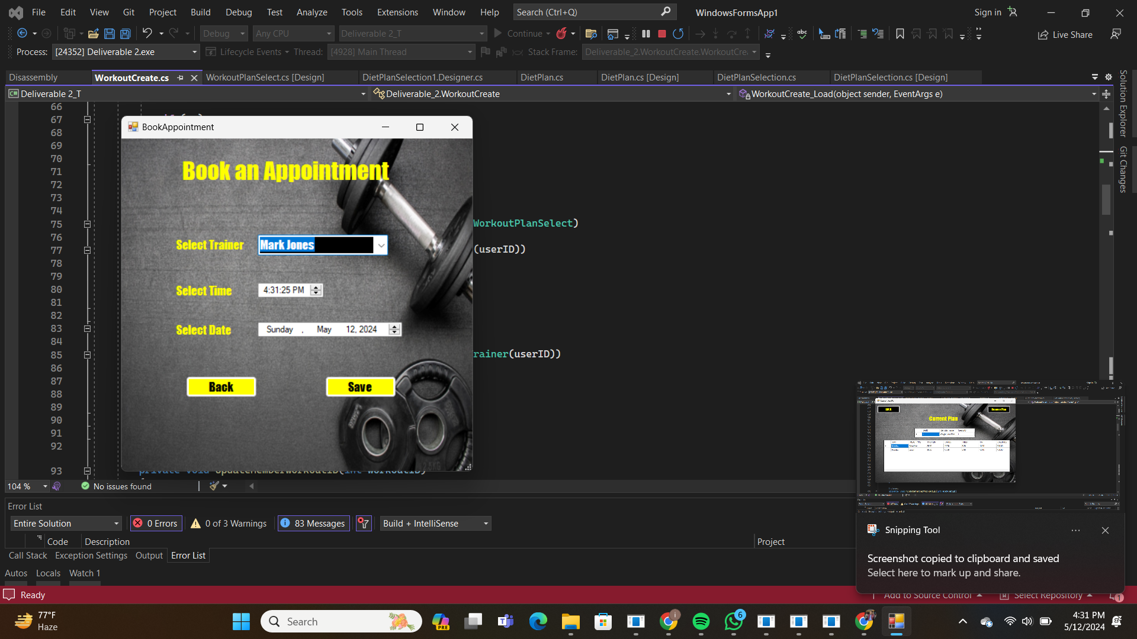

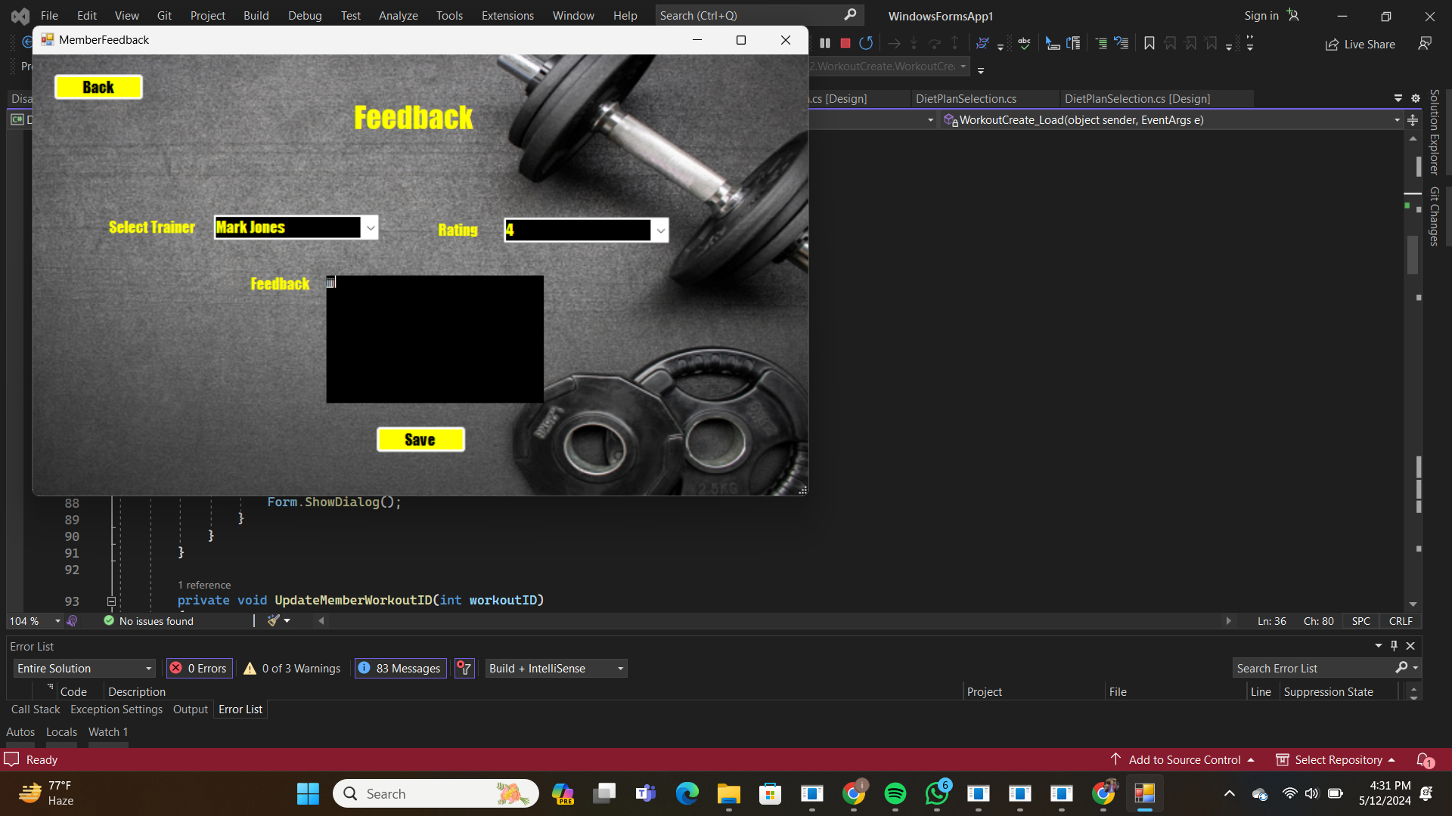

**Trainer interface:**

The form serves as a hub for trainers to create and customize workout plans tailored to individual client needs, fostering effective training programs and client engagement. Additionally, trainers can utilize the form to schedule and manage their client appointments, track progress, and provide feedback, facilitating efficient communication and collaboration for optimal fitness outcomes.

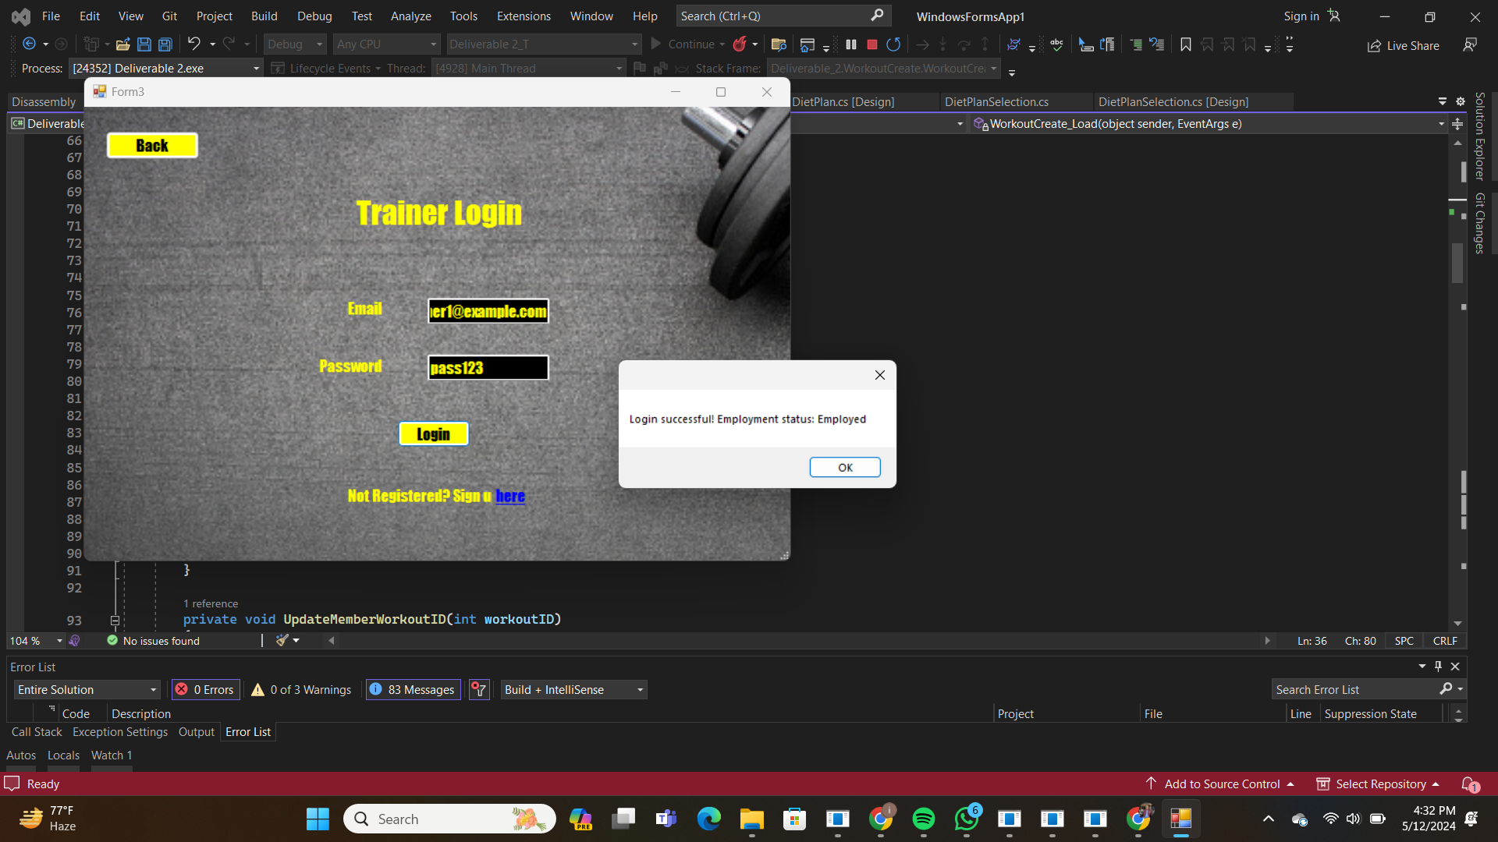

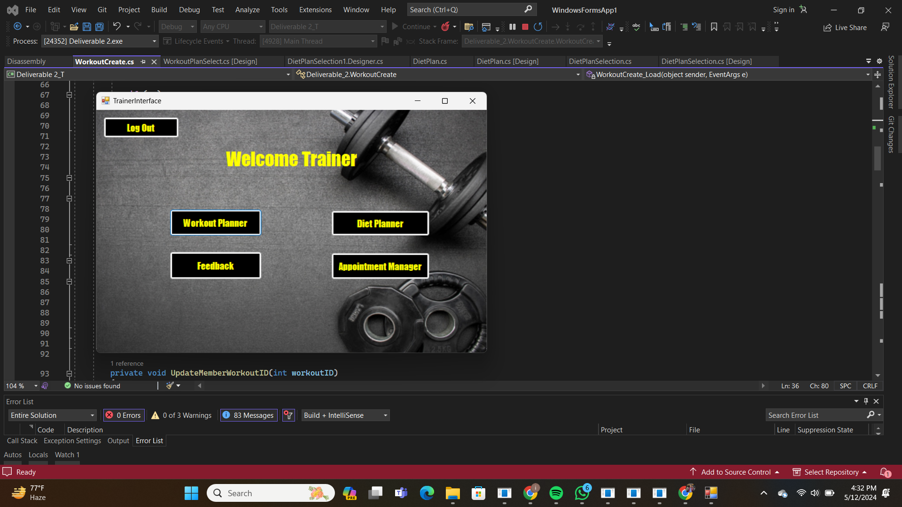

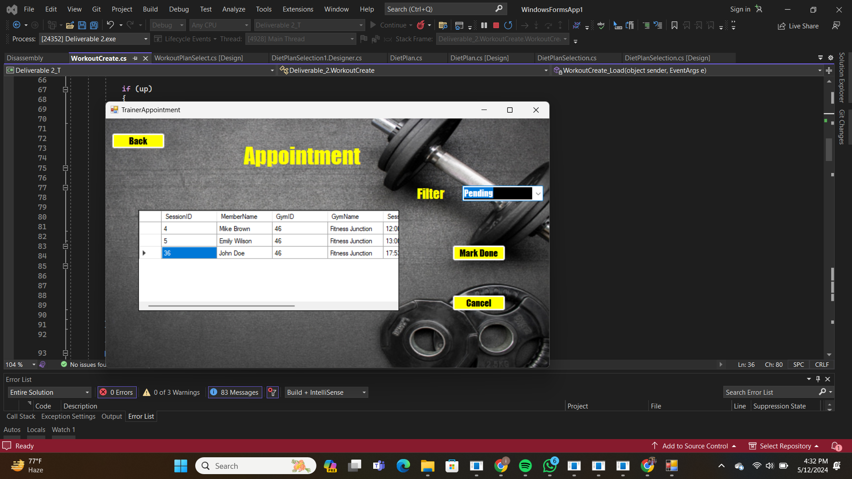

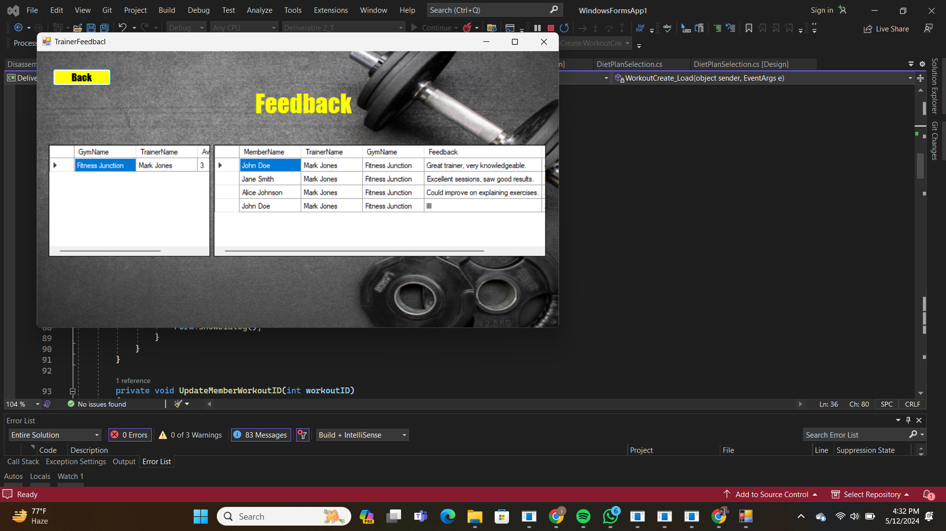

**Owner interface:**

The owner form simplifies the process of managing the gym's operations, enabling owners to oversee various aspects of the business effectively. Owners can use the form to monitor membership statistics, track revenue, and analyze performance metrics, add Trainers to gyms , fire trainers and analyze membership data.

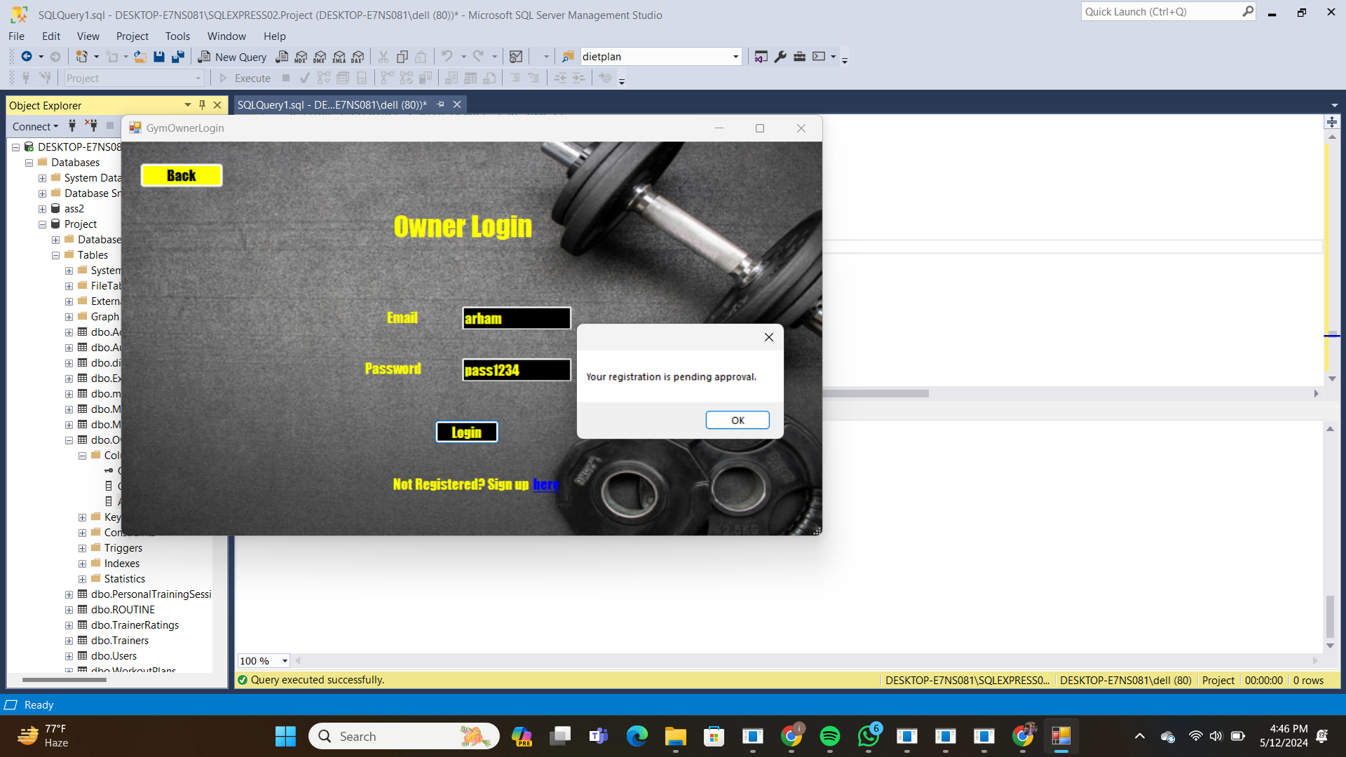

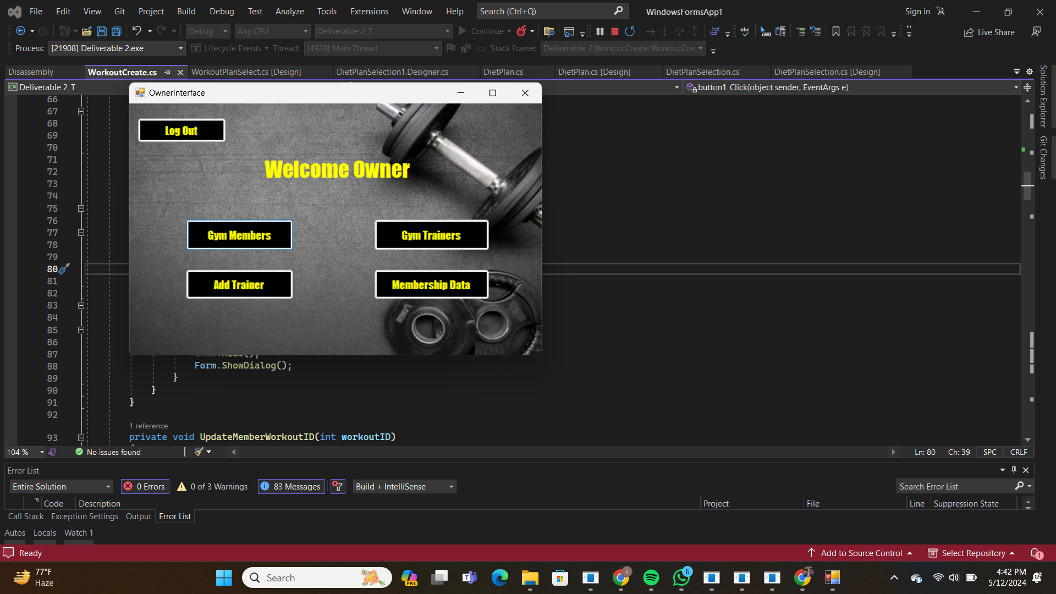

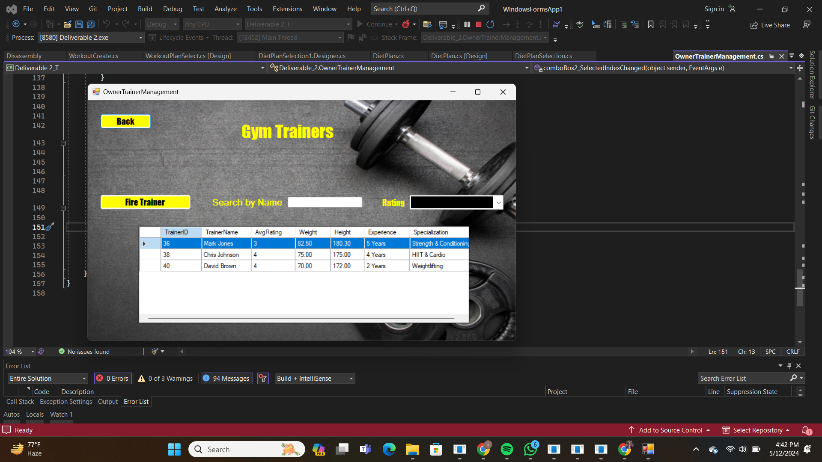

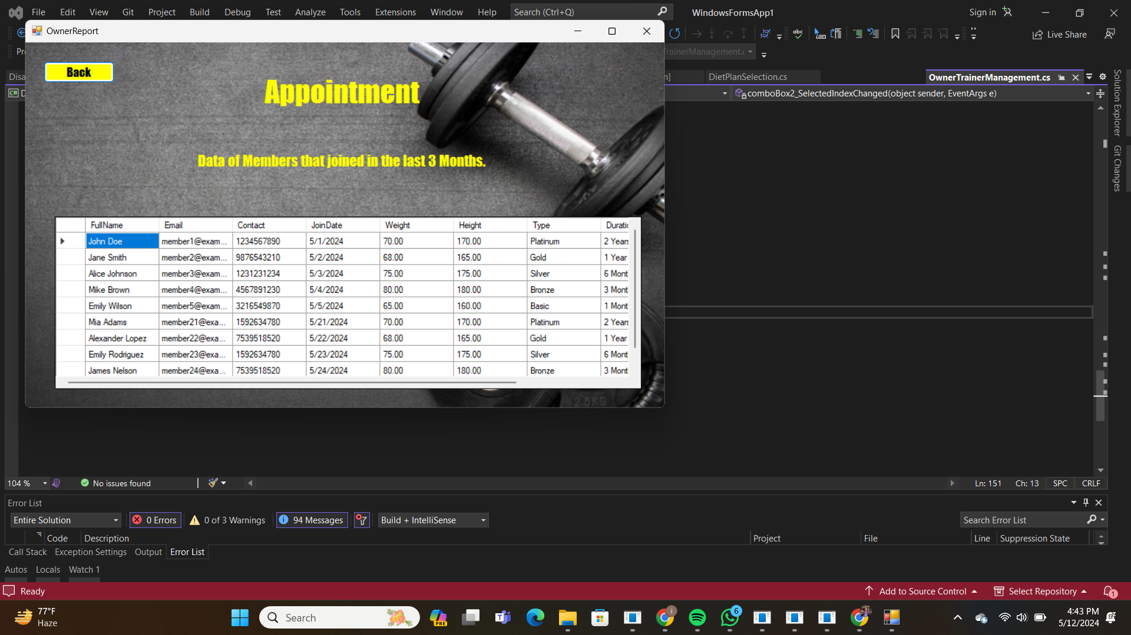

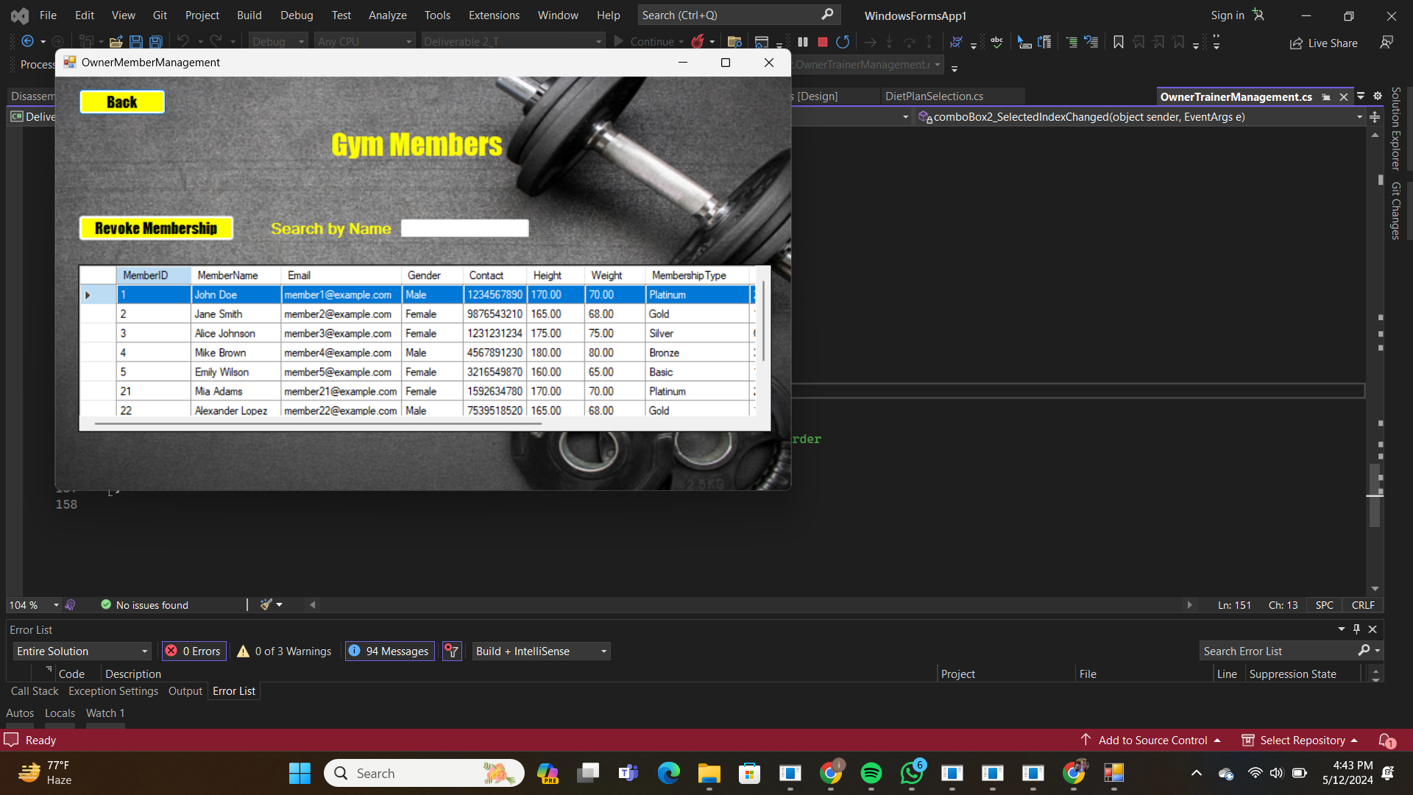

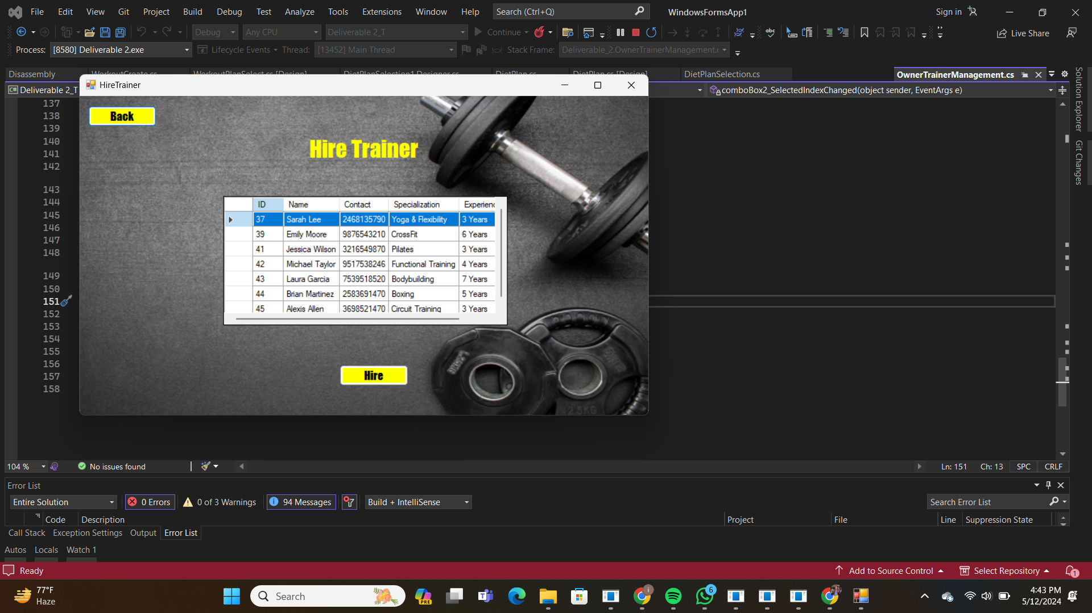

**In the case that owner is not yet approved:**



**Admin interface:**

Admin can approve gym requests from new registered owners , enabling them to manage their accounts on portal , furthermore can analyze data from smart prompts helped to view data effectively and plan strategically

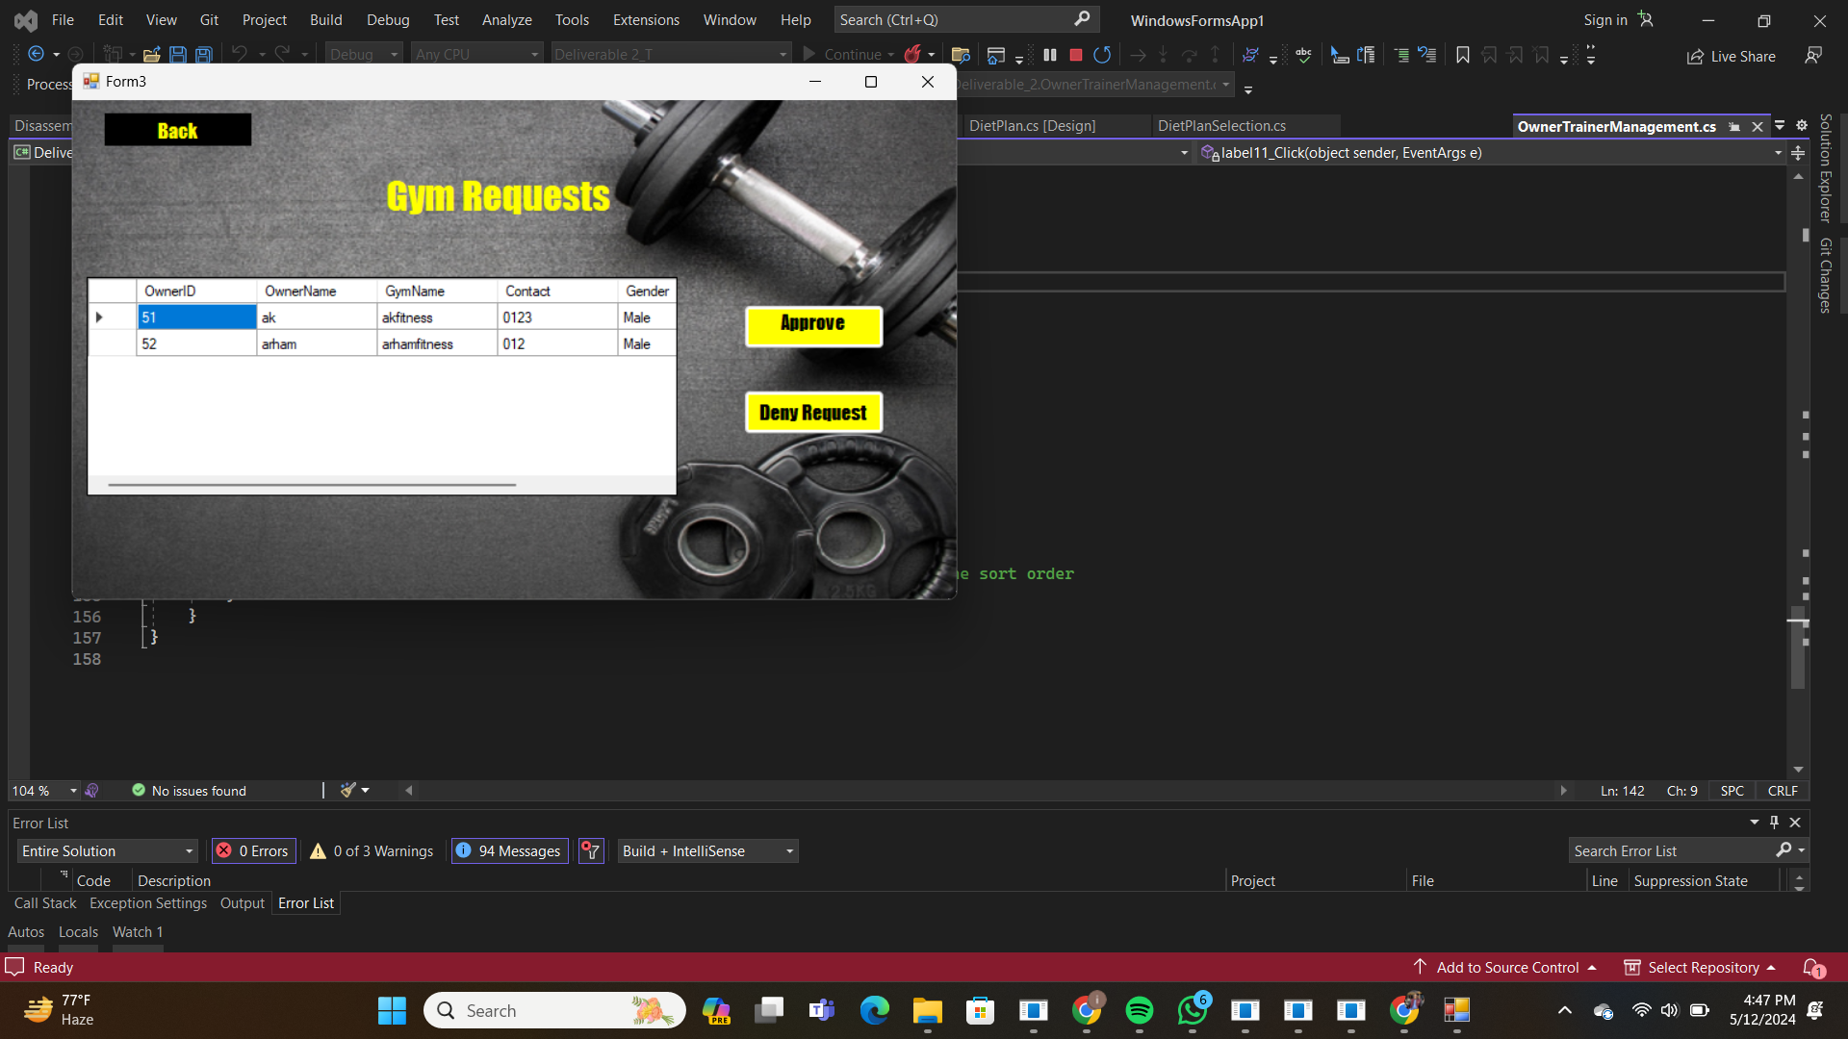

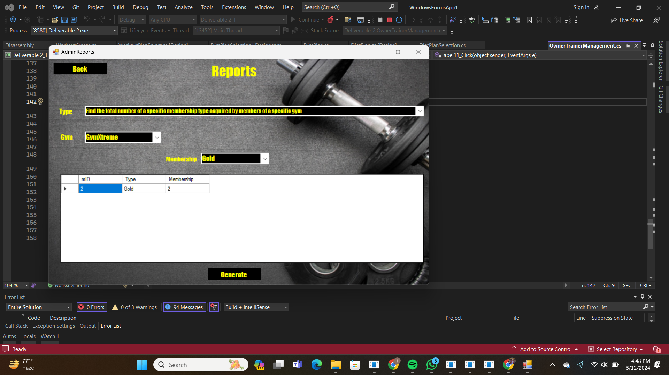

# Changes in schema:

Firstly, we had made workout and exercise table having a many to many relation ,now we have broken it down into 3 tables workout , routine and exercises , one workout plan has multiple routines , one to one relation of exercise and routine

Secondly,we have removed the allergens table.

Thirdly, we have added a membership table , given membership foreign key , a one to many relation ( one type of membership can have multiple members)

# 